Isolation of DNA from Coconut Endosperm
Aim:
To isolate and extract DNA from coconut endosperm by liquid DNA extraction method.
Principle:
The DNA is extracted using suitable extraction medium. Sodium acetate helps neutralize the negative charges on the DNA, which allows them to aggregate and precipitate when cold ethanol is added.
DNA is extracted by liquid DNA extraction method where organic solvents like phenol chloroform, and chloroform isopropyl mixtures are used. The main principle involved is the solubility where DNA is polar in nature with a net negative charge on its backbone, due to which, it remains in the upper aqueous layer. Phenol denatures the proteins, causing their hydrophobic parts to interact and collect at the bottom organic phase
Thus, two immiscible phases are formed. The phenol containing protein component is denser than water and settles to the bottom, while the water containing DNA will be on top. Further, the DNA dissolved is precipitated out by adding ice cold absolute ethanol.
Materials Required:
- Coconut Endosperm
- Mortar and Pestle
- Lysis Buffer (2g TAB, 10 ml 1M Tris (pH 8.0), 4ml 0.5M EDTA (pH 8.0), 28 ml 5M NaCl, 40ml water, 1g PVP40. Adjust all pH to 5.0 and make up to 100ml volume).
- Phenol: Chloroform (1:1)
- Chloroform: Isopropanol (24:1)
- Sodium Acetate (7.5M)
- Cold Absolute Ethanol
Procedure:
- Take about 250 mg of coconut endosperm and homogenize in mortar and pestle with lysis buffer.
- Make up the volume to 10 ml and incubate at 50 degree Celsius for 5 mins.
- Add 5ml of Phenol Chloroform mixture and centrifuge at 3000rpm for 10 mins.
- Take only the supernatant and add chloroform isopropyl mixture (24:1) and centrifuge at 5000 rpm for 3 mins.
- Two phases are formed as shown in Figure 2. The aqueous phase is taken and to this, add 0.1 ml of sodium acetate and 2 ml of cold absolute ethanol.
- The precipitated white DNA is extracted and dissolved in TE buffer for quantification.

Observations and Results:
White, thread-like strands of DNA precipitated almost immediately after absolute ethanol was added as shown in the image below. This is spooled with a glass rod for the successful extraction.
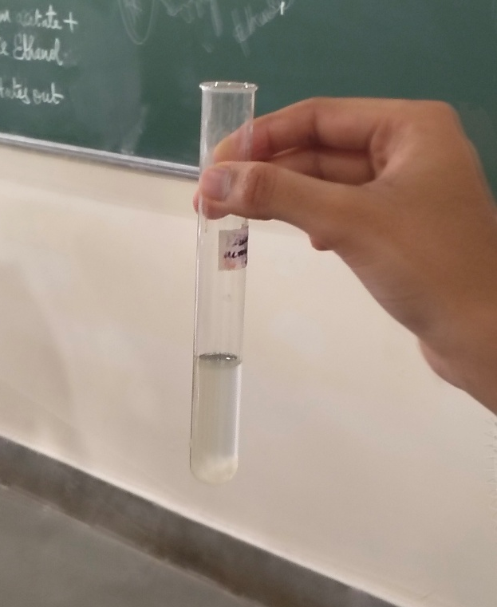
Figure 1: Sample after first centrifugation
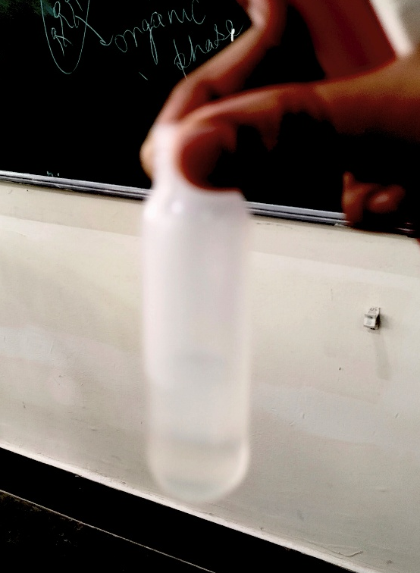
Figure 2: Two immiscible phases after second centrifugation
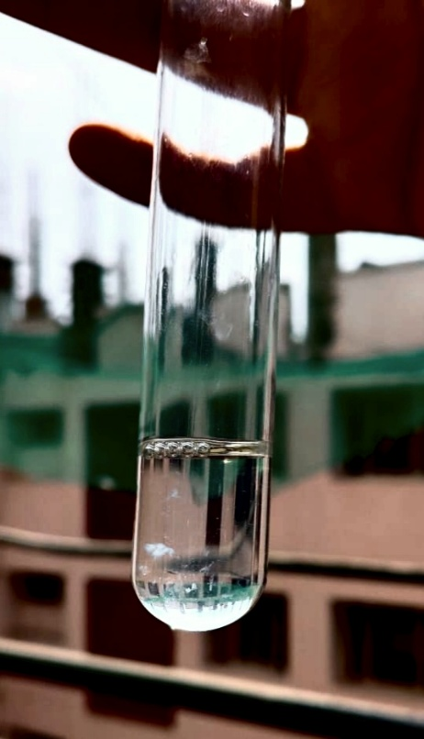
Figure 3: DNA extracted from Coconut Endosperm

Conclusion:
DNA strands were successfully isolated from coconut endosperm using liquid-liquid extraction and was stored in the TE buffer.

